Lab No. 9
Sorting (Bubble Sort and Merge Sort)
Task 1
Write a C++ program to implement Bubble Sort for ascending and descending order.
Display the array before and after sorting.
Program:
#include <iostream>
using namespace std;

void printArray(int arr[], int n) {
for (int i = 0; i < n; i++) {
cout << arr[i] << " ";
}
cout << endl;
}
// accending
void bubbleSortAscending(int arr[], int n) {
for (int i = 0; i < n - 1; i++) {
for (int j = 0; j < n - i - 1; j++) {
if (arr[j] > arr[j + 1]) {
swap(arr[j], arr[j + 1]);
}
}
}
}

// descending
void bubbleSortDescending(int arr[], int n) {
for (int i = 0; i < n - 1; i++) {
for (int j = 0; j < n - i - 1; j++) {
if (arr[j] < arr[j + 1]) {
swap(arr[j], arr[j + 1]);
}
}
}
}
int main() {
int arr[] = { 7,3,1,5,7,9,2,4,8,1 };
int n = 10;

int asc[10], desc[10];
for (int i = 0; i < n; i++) {
asc[i] = arr[i];
desc[i] = arr[i];
}

cout << "Org Array ";
printArray(arr, n);

// Ascending
bubbleSortAscending(asc, n);
cout << "ascending order ";
printArray(asc, n);

// Descending
bubbleSortDescending(desc, n);
cout << "descending order ";
printArray(desc, n);
return 0;
}
Output: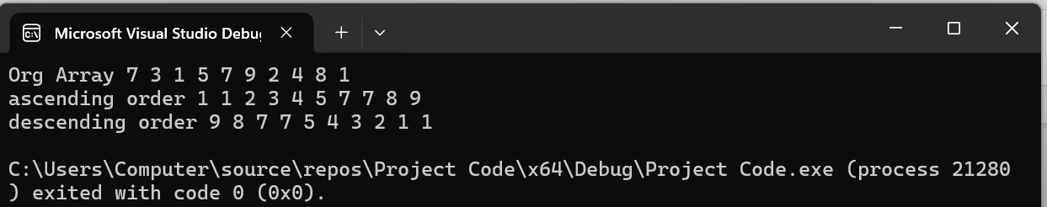
Task 2
Write a C++ program to implement Merge Sort for ascending and descending order.
Display the array before and after sorting.
Program:
#include <iostream>
using namespace std;
void print(int arr[], int n) {
for (int i = 0; i < n; i++)
cout << arr[i] << " ";
cout << endl;
}
// Merg fun acc
void mergeAsc(int arr[], int l, int m, int r) {
int temp[100], i = l, j = m + 1, k = 0;

while (i <= m && j <= r) {
if (arr[i] < arr[j])
temp[k++] = arr[i++];
else
temp[k++] = arr[j++];
}
while (i <= m) temp[k++] = arr[i++];
while (j <= r) temp[k++] = arr[j++];

for (i = l, k = 0; i <= r; i++, k++)
arr[i] = temp[k];
}

// Merge sort Asc
void mergeSortAsc(int arr[], int l, int r) {
if (l < r) {
int m = (l + r) / 2;
mergeSortAsc(arr, l, m);
mergeSortAsc(arr, m + 1, r);
mergeAsc(arr, l, m, r);
}
}
// Merge fun dec
void mergeDesc(int arr[], int l, int m, int r) {
int temp[100], i = l, j = m + 1, k = 0;

while (i <= m && j <= r) {
if (arr[i] > arr[j])
temp[k++] = arr[i++];
else
temp[k++] = arr[j++];
}

while (i <= m) temp[k++] = arr[i++];
while (j <= r) temp[k++] = arr[j++];

for (i = l, k = 0; i <= r; i++, k++)
arr[i] = temp[k];
}

// Merge sort dec
void mergeSortDesc(int arr[], int l, int r) {
if (l < r) {
int m = (l + r) / 2;
mergeSortDesc(arr, l, m);
mergeSortDesc(arr, m + 1, r);
mergeDesc(arr, l, m, r);
}
}
int main() {
int arr[] = { 7,3,1,5,7,9,2,4,8,1 };
int n = 10;

int a[10], d[10];

// copy array
for (int i = 0; i < n; i++) {
a[i] = arr[i];
d[i] = arr[i];
}
cout << "orig ";
print(arr, n);
mergeSortAsc(a, 0, n - 1);
cout << "ascending ";
print(a, n);
mergeSortDesc(d, 0, n - 1);
cout << "descending ";
print(d, n);

return 0;
}
Output: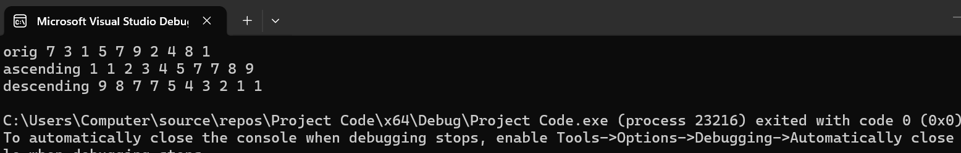
Task 3
Use Bubble Sort OR Merge Sort to sort the array. Then find and display:
- Kth smallest element
- Kth largest element
Input K from the user.
Program:
#include <iostream>
using namespace std;

void bubbleSort(int arr[], int n) {
for (int i = 0; i < n - 1; i++) {
for (int j = 0; j < n - i - 1; j++) {
if (arr[j] > arr[j + 1]) {
swap(arr[j], arr[j + 1]);
}
}
}
}
int main() {
int arr[] = { 7, 3, 1, 5, 7, 9, 2, 4, 8, 1 };
int n = 10;
int k;

cout << "Enter value of K: ";
cin >> k;
bubbleSort(arr, n);

cout << "\nSorted Array: ";
for (int i = 0; i < n; i++) {
cout << arr[i] << " ";
}
if (k > 0 && k <= n) {
int kthSmallest = arr[k - 1];
int kthLargest = arr[n - k];

cout << "\nKth Smallest Element: " << kthSmallest;
cout << "\nKth Largest Element: " << kthLargest;
}
else {
cout << "\nInvalid value of K!";
}

return 0;
}
Output:
